**Set DC Motor speed with potentiometer, PIC and PWM**

Table of contents

1. Introduction
2. Hardware
3. Software
4. Introduction

This application uses a potentiometer to control the duty cycle of the PWM signal sent to the DC Motor. The PIC MCU takes the analog input of the potentiometer and stores it’s position through ADC conversion. The value stores is transformed into the duty cycle of the PWM signal send to the motor. The signal sent to the motor is composed of a square wave with a period of one second, and the duty cycle represents the rapport between the time spent on and the time spent off. For example a duty cycle of 50% means that the signal is HIGH 0.5 seconds and is LOW for 0.5 SECONDS.

1. Hardware

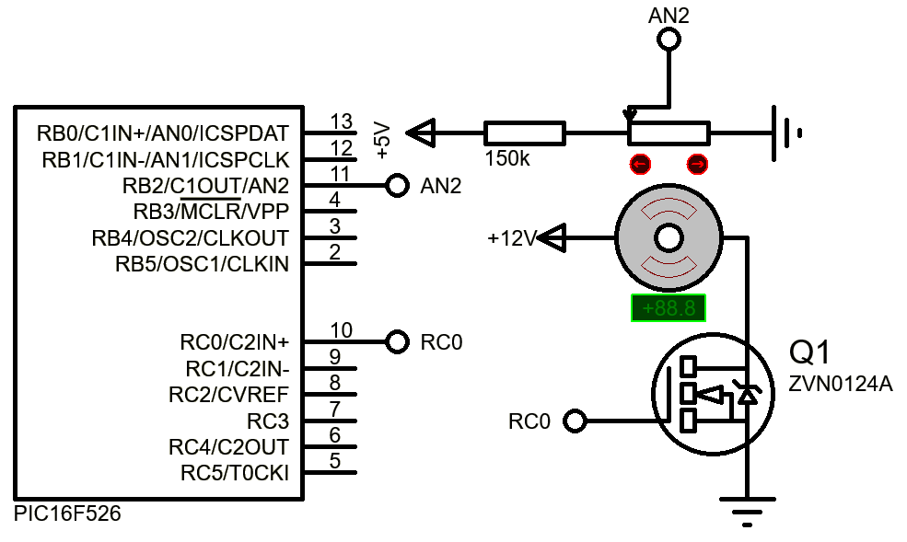

Potentiometer - min: 3.2Ω max: 9.6kΩ

1. Software

The source code is provided in a separate folder and it was written in assembly. The ADC conversion from the potentiometer is stored in “delay” register(GPR), RC0 is set HIGH for “delay” time which is **round(0.0152587891 * Tms)** eg. delay = 15 is ~ 1000ms ~ 1sec.

Then delay = 15 - delay, RC0 is set LOW for “delay” time.

For a duty cycle of 50% the first delay is set to 7 that means RC0 is HIGH for ~0.5 seconds and the second delay is set to 8 that means RC0 is LOW for ~0.5 seconds. The motor speed is very low when delay1 = 0, delay2 = 15 and is very high when delay1 = 15 and delay2 = 0.